2015 CSRA BUDDY WALK DONATION COLLECTION FORM

Instructions:
- Fill in name, team name (if applicable).
- Make donations in cash, check, or money order payable to Upside of Downs. Specify team name or individual name on all checks.
- All contributions must accompany your Donation Form.
- Mail donations to Upside of Downs, 7 Julie Ann Ct, Aiken, SC 29801 or bring to the Buddy Walk on the day of the event.
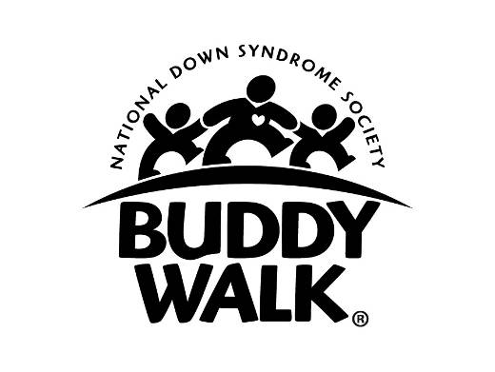

NAME:____________________________________________________ BUDDY: _________________________

TEAM NAME: ____________________________________________

NAME OF DONOR | ADDRESS (CITY, STATE, ZIP) | TELEPHONE | DONATION

Thank you for your support of the Upside of Downs, National Down Syndrome Society and the Buddy Walk program. A receipt for tax purposes will be provided upon request provided we have the full name and address of the donor.

