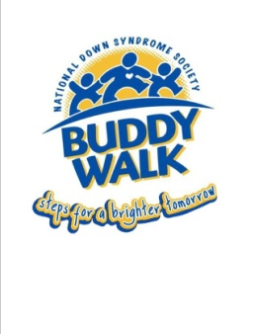 Buddy Walk Registration Form
Saturday, October 3, 2015 (Rain or Shine)
USC Aiken Quad
Aiken, SC
Registration Begins at 9:00 a.m.

Please complete this form and mail to Upside of Downs, c/o Jenny Hall, 7 Julie Ann Ct, Aiken, SC 29801 before September 7, 2015. Registrations will be accepted on the day of the event.

Your Name______________________________________________ Relationship to Buddy____________________

Buddy Name______________________________________________________________________________________

Company/Team Name_____________________________________________________________________________

Street Address____________________________________________________________________________________

City___________________________________State____________________________Zip Code__________________

Phone______________________________________E-mail________________________________________________

Total Number of Walkers______________

Registration is free but T-shirts are $10 per shirt and 1 free for Buddies. Please indicate below how many of each size you would like. Any Buddy raising $100 or more in business sponsors and/or pledges will have their name displayed on the back of the Buddy Walk T-Shirt. T-Shirts/Registrations do NOT count towards the $100 goal and are not deductible.

Free Buddy Shirt _________ (Indicate Youth or Adult Size)

Youth _____XS _____Small _____Medium _____Large

Adult ____Small _____Medium _____Large _____XL _____2XL _____3XL _____4XL

Total Amount $_______________

□ I cannot participate in the walk, but please accept my donation to support programs and services for families with an individual diagnosed with Down syndrome. (Please make checks payable to Upside of Downs)

□ Please add me to your email/mailing list for future Buddy Walks.

I know that participation in a walk, and all other activities occurring at the CSRA Buddy Walk are potentially hazardous activities, which could cause injury or death. I should not participate if I am not medically able and properly trained. I agree to abide by any decision of Buddy Walk officials relative to any aspect of my participation in this event, including the right of the official to deny or suspend my participation for any reason whatsoever. I assume all risks associated with this event, including but not limited to, falls, contact with other participants, batted thrown or kicked balls, the effects of the weather, the condition of the field and any equipment, supplies, or rides, all such risks being known and appreciated by me. Having read this waiver and knowing these facts and in consideration of your accepting my entry, and/or the entry of my minor child (children), I, for myself (and my minor child/children) and anyone entitled to act on my/their behalf, waive and release the University of South Carolina Aiken, the National Down Syndrome Society, Upside of Downs, and all sponsors, their representative, any other persons assisting with the Buddy Walk, and their successors from all claims or liabilities of any kind arising out of my/our participation in the Buddy Walk even though the liability may arise out of negligence or carelessness on the part of the persons named in this waiver. I grant permission to all of the foregoing to use any photographs, motion pictures, recording, or any other record of myself and/or my minor child/children at the event for any legitimate purpose.

Signature_____________________________________________________ Date______________________________

