CSRA Buddy Walk 2015
Team Captain Handbook

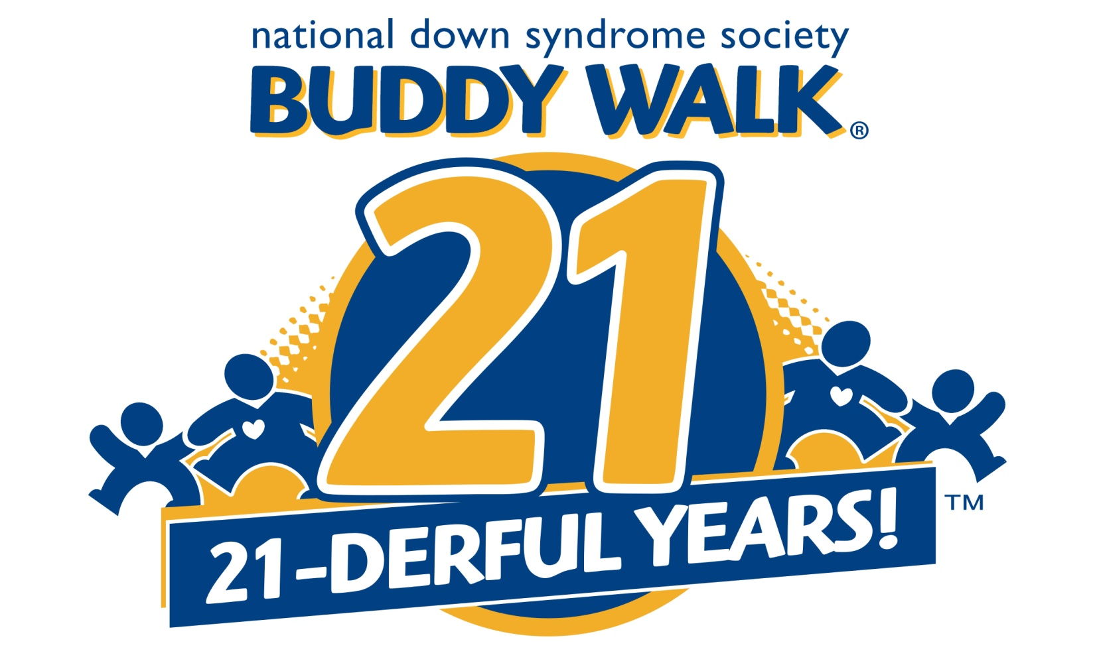

October 3, 2015

info@aikenupsidedowns.org
Jenny Hall (803)648-1652
Karen Strite (706) 799-5347

Welcome Team Captains!

We are very excited about the 8th Annual CSRA Buddy Walk™. The event will be held on Saturday, October 3, 2015, at the USC Aiken Quad.
Last year’s CSRA Buddy Walk™ was a day packed with awareness, family fun and food for all who were present.

If you did not participate last year, some of the things you can expect at this event include:

- Play spaces, including inflatable jumpers
- Crafts
- Music
- Awards
- Areas to gather to make team posters
- Tailgating will be allowed

In addition to being a fun day that raises awareness and acceptance for Down syndrome, the CSRA Buddy Walk™ is an avenue to raise funds to support local and national programs.

There is a lot to do and many opportunities to get involved! You have a devoted committee compiled of professionals, parents and friends. We are here to help you! Whether this is your first time as a Captain or if you have participated in Buddy Walks past, The Buddy Walk™ Committee hopes this packet can provide you with useful ideas and materials to help you organize. Please feel free to contact us with any questions about the Walk or your team.

Here’s to an awesome Walk!

CSRA Buddy Walk™ Committee
info@aikenupsidedowns.org
Jenny Hall (803)648-1652
Karen Strite (706) 799-5347

Table of Contents

- Timeline for the 2015 CSRA Buddy Walk™ 3
- Team Checklist 4
- Down Syndrome Fact Sheet 5
- Buddy Walk FAQ 6
- Directions to Buddy Walk™ 6
- T-Shirts and Awards 7
- Fundraising Incentives 8
- Suggestions for Fund Raising 9-11
- On-Line Fundraising 11
- Buddy Walk™ Day 11
- Forms~ (Copy and use as needed) 12-16
  - Letter- “Join the team” 12
  - General Sponsor Letter 13
  - Sponsorship Form 14
  - Registration Form 15
  - Pledge Sheet 16

Timeline

Now Start asking friends, family members, coworkers,
and local businesses for donations!

September 7, 2015 Deadline for names of Buddies and Sponsors to be placed on shirts (Guarantees a Buddy Walk™ shirt)

October 3, 2015 CSRA Buddy Walk™ 2015!

**Note: There is a committed team to answer any questions that you may have. Please contact us at anytime via phone or email.

Checklist/To Do List

1. Announce Your Team | NOW!
- Tell family, friends, neighbors and coworkers that you are creating a Buddy Walk™ team
- Ask your Buddy Walk™ Committee for support in any of the ideas that you have

2. Register your Team | NOW!
NOTE: Teams may be registered any time prior to the Walk.
- When you have at least 2 people, you have a team!
- Set a team fund-raising goal!
- Request family, friends & associates to sign up and join or support your team!
- Ensure that your team members have access to pledge forms

3. Collect Pledges and Mail or Bring to the Buddy Walk™! | NOW until the end of October
- Team Members can use the Pledge Form included in this packet (Forms; pg. 11)
- Please, do not mail cash!!!
- The deadline for names to be included on our Buddy Walk t-shirt is September 7, 2015.
- NOTE: We are always grateful to receive pledge money collected after the Event Day.

4. Notify your team of the following: | By September 15
- Contact all of your members to remind them of the event, and that it will take place rain or shine.
- Arrange a place for your team to gather on the morning of the event – or arrange to meet at a specific spot (NOT the registration table PLEASE).

Down Syndrome Fact Sheet

What is Down syndrome?

Down syndrome is a genetic condition that occurs in approximately one in every 733 live births. It affects people of all ages, races and economic levels and is the most frequently occurring chromosomal abnormality. It occurs when there are three, rather than two, number 21 chromosomes present in every cell of the body. Instead of the usual 46 chromosomes, a person with Down syndrome has 47. It is this additional genetic material that alters the course of development and causes the characteristics associated with the syndrome. Down syndrome affects over 350,000 people in the United States alone.

What is the Buddy Walk?

The Buddy Walk® was created by the National Down Syndrome Society in 1995 to celebrate Down Syndrome Awareness Month in October and to promote acceptance and inclusion of people with Down syndrome. The Buddy Walk has grown from 17 walks in 1995 to nearly 250 walks planned for 2015 worldwide. In 2014, more than $11.2 million was raised nationwide to benefit local programs and services, as well as the national advocacy initiatives of NDSS that benefit all individuals with Down syndrome.

In addition to its goal of promoting awareness of Down syndrome, the Buddy Walk™ raises money to support the education, research and advocacy programs of NDSS. The National Down Syndrome Society is a nonprofit organization with nearly 275 affiliates nationwide representing the more than 400,000 Americans who have this genetic condition. The organization is committed to being the national leader in supporting and enhancing the quality of life, and realizing the potential of all people with Down syndrome so that they have the opportunity to realize their life aspirations.

With the money raised from this walk, a percentage will go to the NDSS to further research for Down syndrome, a small percentage to host the event and the remainder will go back to the families in this community to sustain our local efforts for enhancing acceptance and inclusion that our families need to help their loved one’s achieve their goals and dreams.

On Saturday, October 3, 2015 we will hold the 8th Annual CSRA Buddy Walk for Down syndrome at the USC Aiken Quad in Aiken, SC. Registration begins at 9:00 a.m. with a walk starting at 10:00 a.m. After the Walk, families and friends celebrate and enjoy the Event Day and the steps we are all taking for a brighter tomorrow.

Buddy Walk Frequently Asked Questions

Why:
- To promote acceptance and inclusion of all people with Down syndrome, and to raise money to support local and national programs.

How:
- Through individuals and teams who seek donations from friends, families and co-workers to sponsor their participation in walks around the country.

When:
- The CSRA Buddy Walk will be held on Saturday, October 3, 2015. Registration begins at 9:00 a.m. with the walk starting at 10:00 a.m. Throughout the month of October, National Down syndrome Awareness Month, more than 250 Buddy Walks will occur throughout the United States and 5 other countries.

Where:

The CSRA Buddy Walk will be held at the USC Aiken Quad with the Walk occurring around the green space, and then post-walk festivities. The address is 471 University Parkway, Aiken, SC 29801

For Driving Directions: http://www.usca.edu/directories/driving2.html
From Augusta via US 1
Take US 1 toward Aiken
Turn left on SC 118, Robert M. Bell Parkway
Turn right on Trolley Line Road
Turn right on University Parkway.
Take the first or second right into parking lot A

From Augusta via I-20
Take I-20 toward Aiken
Take Exit 11 toward Bettis Academy Road
Turn Right on Bettis Academy Road
Turn left on Ascauga Lake Road
Turn Left on Canal Street
Canal Street Become Trolley Line Rd
Turn right on University Parkway.
Take the first or second right into parking lot A

From Columbia via I-20
Take I-20 toward Aiken
Take Exit 22 toward US 1
Turn left on US 1
Turn right on SC 118, Rutland Drive
Turn left on University Parkway.
Take the first or second right into parking lot A

A map of the USC Aiken campus is available at http://web.usca.edu/about-usc-aiken/campus-map/
EVERYONE in the CSRA is invited!
T-Shirts and Awards

All buddies who have submitted a minimum of $100 by September 7, 2015 will have their name listed on the back of our official Buddy Walk t-shirt.

We will order a very limited number of t-shirts above preorders, and those who receive complimentary t-shirts based on sponsorship levels. These will be available for sell at the walk while supplies last.

Preordered t-shirts and sponsor t-shirts will be available for pick-up prior to the Buddy Walk. We will send an e-mail with the date and time you may pick-up the t-shirts. You may also choose to pick-up t-shirts the day of the Buddy Walk.

This year’s t-shirt will be heather grey with the current Buddy Walk logo (the logo on the front of the Team Captain Handbook) on the front and Buddies and sponsors on the back.

If you have a sponsor who donates enough money to qualify for a logo on the shirt, please have them send the logo as a high resolution jpeg.

In the past we have given awards for the oldest buddy, youngest buddy, person who traveled the greatest distance to attend, team with the most spirit at the Buddy Walk, and awards for our top fundraisers. We also present medals to all our Buddies in attendance.

Fundraising Incentives

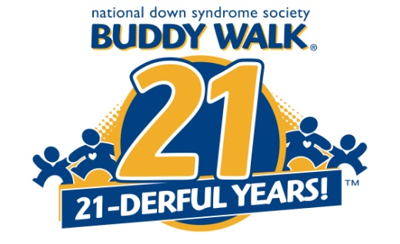

2015 CSRA Buddy Walk Fundraising Incentives

The 2016 National Down Syndrome Congress Convention will be held in Orlando, FL on July 21-24, 2016. Attendance at this event is an excellent way to learn more about various topics related to Down syndrome. The following incentives are offered for fundraising levels for the 2015 CSRA Buddy Walk.

$1,500 – Family registration (up to three people in the same household) for the 2016 NDSC Convention at the price of the first deadline ($260). An additional person may also be added ($50)

$2,000 –Up to four banquet tickets ($45 for adults/$19 for children)

$2,500 – Up to two registrations for the Youth & Adults with Down Syndrome Conference {must be 15 ($85)}, Bothers & Sisters Conference {Rising 4th – 12th graders ($85)}, and/or Kids Camp {6 months -14 (up to $150)}

$3, 500 – Up to three nights stay at the host hotel ($145)

Prices are based on 2015 convention prices, and will change based on the price of the 2016 NDSC Conference.

Dollar incentives are for cash raised. In-kind donations are not included in the total.

Fundraising Ideas

How to Raise $500 in 7 days:

Day | Details | Total
1 | Sponsor yourself for $25 | $25
2 | Ask three family members/ housemates for $25 | $100
3 | Ask five friends to donate $15 | $175
4 | Ask five co-workers to sponsor you for $10 | $225
5 | E-mail 15 people & ask for a $10 donation | $375
6 | Ask your company for a $75 contribution | $450
7 | Ask two businesses you frequent for $25 | $500

START SOON!
- Start early and set a goal!
A group of two or more participants constitutes a team. Designate one person as your team captain, choose an original team name, and you are on your way to success. Develop a goal for you and your team, and encourage each team member to set his or her own goal, too.

RECRUIT TEAM MEMBERS AND RAISE MONEY!
- Be a great example. Start by making your own pledge toward your team’s goal.
- Grow your team. Start with people who are close to you, but don’t stop there! You never know who is interested until you invite them to join you! Ask family members, friends, neighbors, business associates, and others in the community (your favorite waitress, doctor, mail carrier, therapists, etc.) If a person is unable or unwilling to join the team, ask for a donation. Don’t be afraid to talk to business owners about sponsorship. If there are any groups that your team would like to present to, let the Buddy Walk™ Committee assist you with materials or any other support they can offer.
- Encourage your teammates to spread the word and invite others to join your team or to start one of their own.
- Contact potential teammates in person or by phone, via e-mail or through the mail (handwritten notes are especially powerful!—include a photo of the person with Down syndrome who inspired you to be a part of the Buddy Walk™). Explain why the Buddy Walk™ is important to you, why you are involved and why you would like them to be involved.
- Pledges collected through cash or check should be obtained when the donor makes a commitment to support your efforts, and all pledges should be recorded on a pledge sheet. Team members should turn in their pledge sheets and pledges to you, the Team Captain.
- When you have recruited your team, hold a team meeting to get your members more involved and excited. See how successful they have been collecting pledges, and use the information included in this packet to provide ideas for further fundraising and encouragement.

- Provide a copy of the Pledge Form to each Team Member, and promote a little healthy competition in your team:
  - Encourage walkers to reach a certain financial goal
  - Have your team members suggest team names and vote to determine the favorite.
  - Make sure team members have access to information about Down syndrome, the Buddy Walk™, and both Upside of Downs and NDSS that they may reference to answer questions raised by donors. (See attached Facts about…sheets)
  - Remind your team members to think about their schools, businesses and religious organizations as places to recruit team members advertise the walk and gather pledges.
  - To get your Buddy’s school involved, you may want to approach the Buddy Walk™ as an educational opportunity (October is National Down Syndrome Awareness Month!). A project might involve a whole school, or just one class, and can include large scale ideas, such as having children bring in $5 to be able to participate in a “dress down day” or “silly hat day”, or smaller, simpler ideas such as a penny drive or a donut sale. Students can participate in a letter writing assignment, writing to people who live out of state, with prizes awarded to the student who brings in a check from furthest away. A template can be provided by the Buddy Walk Committee and customized for your school.
  - Faith Communities can be involved by posting information, handing out brochures and accepting donations after services, making announcements from the pulpit, and including announcements in weekly bulletins or internet postings.
  - Boy or Girl Scouts may be eligible to earn a variety of badges by participating in the Buddy Walk™.
  - Encourage team members to utilize company newsletters, email, bulletin boards, paycheck stuffers, etc., to advertise your team. Make sure everyone knows how to contact you to join the team or make a donation.
  - Make sure team members have access to pledge forms and donation sheets.

- Ask everyone you meet: Even if you have sent out letters, be sure to carry a sponsor/donation form with you so that when you talk to people about the Buddy Walk, you can ask them to donate right then. Don't prejudge whether people will give--just ask!

- Block Party: Have a neighborhood block party. Sell food and charge admission

- Brown Bag Lunch Day: Encourage employees to bring in their own lunches and donate the money they would have spent to the team

- Down syndrome Denim Days or Dress Down For Down syndrome: Ask your company CEO/President to let staff dress casual or wear denim for a $5.00 or more donation

- Magical Mondays: Work out an arrangement with your employer to make flavorful Hazelnut or French Vanilla coffee in place of the regular every Monday and request a dollar donation for a steamy cup from co-workers. (Supplying real creamer works well!) Include a sign that explains Buddy Walk (one can be provided to you if you don’t have a way to create your own)

- Monday Night Football Party with a Purpose: Provide refreshments and charge admission to the game.

- Pancake Breakfast: Hold a pancake breakfast at work, or at a church or social hall

- Other Ways to Raise Money for the Buddy Walk: Car washes, a dog wash, garage sales, “Dimes for Down syndrome Day” at work or at your child’s school. Encourage walkers to get pledges from family, friends, colleagues, doctors, dentists, dry cleaners, hairdressers, and places where they are frequent patrons

On-Line Fundraising

A secure on-line giving option has been established through FirstGiving. The web address is http://www.firstgiving.com/upsideofaiken/2015-csra-buddy-walk. Donating through this website is simple, fast and totally secure.

This site gives you the opportunity to create a team to raise funds for the CSRA Buddy Walk, join an existing fundraising team, or simply make a donation. Once you have created your personalized page for the CSRA Buddy Walk, you can send the link to friends and family, or share it on a social networking site.

Buddy Walk Day – October 3, 2015

- You can arrive early to the Buddy Walk. Please feel free to bring along pop-up tents, tailgating foods, balloons, signs, etc. to help your team members find you. Space is available for teams to set up and gather together. We will have FREE food and drinks available. Additionally, there will be merchandise for sale, and a silent auction.

- When your team has arrived, collect all of the pledges and other donations from your members, complete your totals on the roster, and bring it all to the Team Registration table.

- Go to the Team Registration Table between 9:00 and 10:00 a.m. If you have not yet received your T-shirts, all of this will be given to you when you check in that morning.

- Enjoy the activities happening before and after the Buddy Walk.

Thank your team members and sponsors. It is important to stay in touch with your sponsors throughout the year, and let them know how much you appreciate their involvement and commitment. A card with a picture of their “Buddy” is a great way to keep their hearts with you.

Be proud of your contribution – YOU have made a difference!!!
^{Sample Letter -“Join the Team”}
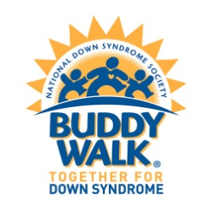
^{(YOUR NAME / TEAM NAME)}
^{(ADDRESS)}
^{(CITY, STATE, ZIP)}
^{(PHONE NUMBER)}
^{(E-MAIL ADDRESS)}
^{(DATE)}

^{Dear Friends,}

I am excited about participating in the upcoming Buddy Walk™ benefiting Upside of Downs, the National Down Syndrome Society, and families in our community. I could really use your help! This is a great event that raises money to promote awareness for all individuals with Down syndrome. In addition, we raise money to support local programs and national research, education and advocacy efforts. These funds have paid for play groups, information meetings, social events, and Down syndrome Conference attendance for families. The Buddy Walk ™will be held on October 3, 2015 at the USC Aiken Quad in Aiken, SC. Registration is at 9:00 a.m. with the walk at 10:00 a.m. It is a fun and heart-warming day with the walk itself, followed by food, fun, games and music. Come be a part of this great day and do your part to help promote awareness and acceptance of people with Down syndrome.

^{You can help by:}
º Joining our team and making a contribution
º Walking on our team and asking your friends, family or co-workers to support you (raise money and qualify for great prizes!)
º Forming your own walk team (become a team captain and inspire others to seek donations for the Buddy Walk™.)
º Passing on the walk but making a contribution

Down syndrome is a chromosomal disorder that affects one of every 700 live births. It is one of the leading clinical causes of intellectual disability in the world. Individuals with Down syndrome are at higher risk for medical problems and language delays. Quality educational programs, along with a stimulating home environment and good medical care, enable individuals with Down syndrome to become contributing members of their families and communities.

Your support of (TEAM NAME) will help individuals with Down syndrome and their families. I hope you’ll join our team. We look forward to seeing you on October 3, 2015 at the USC Aiken Quad in Aiken, SC.

^{Thank you,}
^{(YOUR NAME)}

Note: Please put my name/team name on the memo line and the words “Buddy Walk™”
Please make checks payable to: Upside of Downs. All gifts are tax deductible under appropriate laws.
^{Mail to: (YOUR ADDRESS)}

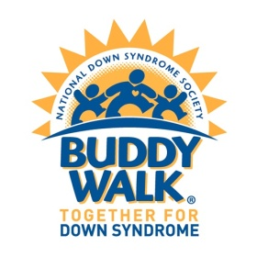

Date

Dear Friend,

In October, we will celebrate eight years of coordinating Buddy Walks in the CSRA. This year we are kicking off the 8th annual CSRA Buddy Walk™ in Aiken, SC. The CSRA Buddy Walk™ will be held on October 3rd at the USC Aiken Quad in Aiken, SC. Last year our Buddy Walk™ had over 300 attendees and 42 individuals with Down syndrome were team captains.

The goal of the Buddy Walk™ is to promote understanding and acceptance and inclusion of people with Down syndrome. In addition, we raise funds to support families of individuals with Down syndrome, local support programs, and help research efforts by the National Down Syndrome Society.

The Buddy Walk™ was established by the National Down Syndrome Society (NDSS) to promote acceptance and inclusion of people with Down syndrome and to celebrate Down Syndrome Awareness Month in October. It has evolved into the single largest awareness vehicle for Down syndrome in the world. It is a major platform for inclusion in communities nationwide.

We hope you will join in this important effort by supporting this year’s events. Your tax-deductible donation will help all people with Down syndrome step towards a brighter tomorrow.

Thank you very much for your generosity and support. I look forward to hearing from you soon. Our non-profit tax ID is 27-3358281. If you have any questions or need additional information, please call Jenny Hall (803) 648-1652 or Karen Strite (706) 799-5347.

Sincerely,

CSRA Buddy Walk™ Committee
info@aikenupsidedowns.org

Special Buddy : ________________________________________________________________________________
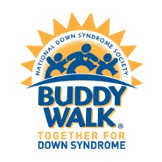
Company Name*: ______________________ _______________________________________________________
(*As it should appear on recognition materials, such as t-shirts and on site signage)
Contact Person: ________________________________________________________________________________
Address: _________________________________________________________________________________________
City: _________________________________________ State: __________________ Zip Code: ______________
Phone Number: ___________________________________ Fax Number: ____________________________
Email: ____________________________________________________________________________________________
I would like to support the Buddy Walk™ by becoming a(n):

□MVP Sponsor for a gift of $3,000
• Logo prominently featured on Buddy Walk™ t-shirts
• Logo featured on Sponsor Board at the Walk and on promotional materials.
• Sponsor’s name mentioned during day’s events
• Link to sponsor’s website on CSRA Buddy Walk page on Upside of Downs of Aiken website
• Able to display banner at CSRA Buddy Walk
• *Please forward your logo in a JPEG or TIFF file to Jenny Hall at info@aikenupsidedowns.orgc
□Home run sponsor for a gift of $1,000
• Logo prominently featured on Buddy Walk™ t-shirt.
• Logo featured on Sponsor Board at the Walk and on promotional materials.
• Sponsor’s name mentioned during the day’s events
• Link to sponsor’s website on CSRA Buddy Walk page on Upside of Downs of Aiken website
• *Please forward your logo in a JPEG or TIFF file to Jenny Hall at info@aikenupsidedowns.org
□Triple Sponsor for a gift of $500
• Sponsor’s name in typesetting on Buddy Walk™ t-shirt
• Sponsor’s name listed on Sponsor Board at the Buddy Walk™
• Sponsor’s name mentioned during the day’s events
• Sponsor’s name listed on CSRA Buddy Walk page on Upside of Downs of Aiken website
□Double Sponsor for a gift of $250
• Sponsor’s name in typesetting on the Buddy Walk™ t-shirt
• Sponsor’s name listed on Sponsor Board at the Buddy Walk™
• Sponsor’s name listed on CSRA Buddy Walk page on Upside of Downs of Aiken website
□Single Sponsor for a gift of $100
• Sponsor’s name listed on Sponsor Board at the Buddy Walk™
• Sponsor’s name listed on CSRA Buddy Walk page on Upside of Downs of Aiken website

□ Yes! I would like to receive three shirts as a thank you for my participation.

Adult: S, M, L, XL, XXL, XXXL; Youth: XS, S, M, L

T-shirt # 1 ________ # 2 _________ # 3 _________

   No thank you, I don’t need shirts.

Please make checks payable to Upside of Downs.
Please mail to: Upside of Downs, c/o Jenny Hall, 7 Julie Ann Court, Aiken SC 29801
All commitments must be received no later than September 7, 2015 to have logo placed on T-Shirt.

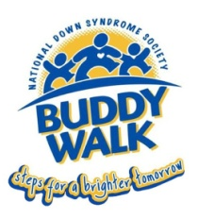
Buddy Walk Registration Form
Saturday, October 3, 2015 (Rain or Shine)
USC Aiken Quad
Aiken, SC
Registration Begins at 9:00 a.m.

Please complete this form and mail to Upside of Downs, c/o Jenny Hall, 7 Julie Ann Ct, Aiken, SC 29801 before September 7, 2015. Registrations will be accepted on the day of the event.

Your Name_______________________________________ Relationship to Buddy__________________

Buddy Name_____________________________________________________________________________

Company/Team Name____________________________________________________________________

Street Address___________________________________________________________________________

City________________________________State______________________Zip Code__________________

Phone_________________________________E-mail_____________________________________________

Total Number of Walkers______________
Registration is free but T-shirts are $10 per shirt and 1 free for Buddies. Please indicate below how many of each size you would like. Any Buddy raising $100 or more in business sponsors and/or pledges will have their name displayed on the back of the Buddy Walk T-Shirt. T-Shirts/Registrations do NOT count towards the $100 goal and are not deductible.

Free Buddy Shirt _________ (Indicate Youth or Adult Size)

Youth _____XS _____Small _____Medium _____Large

Adult ____Small _____Medium _____Large _____XL _____2XL _____3XL _____4XL

Total Amount $_______________
□ I cannot participate in the walk, but please accept my donation to support programs and services for families with an individual diagnosed with Down syndrome. (Please make checks payable to Upside of Downs)

□ Please add me to your email/mailing list for future Buddy Walks.

I know that participation in a walk, and all other activities occurring at the CSRA Buddy Walk are potentially hazardous activities, which could cause injury or death. I should not participate if I am not medically able and properly trained. I agree to abide by any decision of Buddy Walk officials relative to any aspect of my participation in this event, including the right of the official to deny or suspend my participation for any reason whatsoever. I assume all risks associated with this event, including but not limited to, falls, contact with other participants, batted thrown or kicked balls, the effects of the weather, the condition of the field and any equipment, supplies, or rides, all such risks being known and appreciated by me. Having read this waiver and knowing these facts and in consideration of your accepting my entry, and/or the entry of my minor child (children), I, for myself (and my minor child/children) and anyone entitled to act on my/their behalf, waive and release the University of South Carolina Aiken, the National Down Syndrome Society, Upside of Downs, and all sponsors, their representative, any other persons assisting with the Buddy Walk, and their successors from all claims or liabilities of any kind arising out of my/our participation in the Buddy Walk even though the liability may arise out of negligence or carelessness on the part of the persons named in this waiver. I grant permission to all of the foregoing to use any photographs, motion pictures, recording, or any other record of myself and/or my minor child/children at the event for any legitimate purpose.

Signature___________________________________________________ Date________________________

2015 CSRA BUDDY WALK DONATION COLLECTION FORM

Instructions:
- Fill in name, team name (if applicable).
- Make donations in cash, check, or money order payable to Upside of Downs. Specify team name or individual name on all checks.
- All contributions must accompany your Donation Form.
- Mail donations to Upside of Downs, 7 Julie Ann Ct, Aiken, SC 29801 or bring to the Buddy Walk on the day of the event.
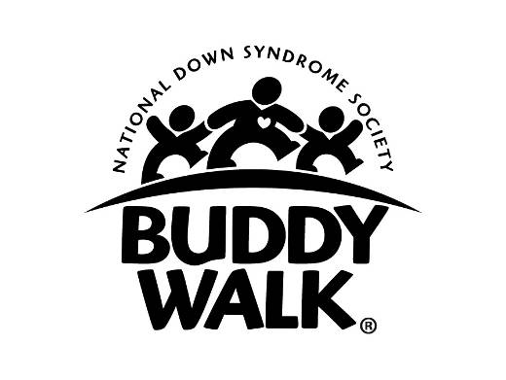
NAME:____________________________________________________ BUDDY: _________________________

TEAM NAME: ____________________________________________

NAME OF DONOR | ADDRESS (CITY, STATE, ZIP) | TELEPHONE | DONATION

Thank you for your support of the Upside of Downs, National Down Syndrome Society and the Buddy Walk program. A receipt for tax purposes will be provided upon request provided we have the full name and address of the donor.

