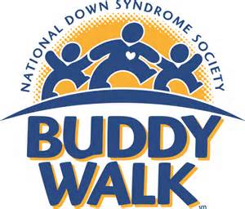
You are invited to the eighth annual CSRA Buddy Walk

When: Saturday, October 3, 2015
Registration at 9:00am, the Buddy Walk at 10:00am

Where: The Quad on the Campus of the University of South Carolina Aiken
471 University Parkway, Aiken, SC 29801

Join the Upside of Downs, Inc. (Augusta) and the Upside of Downs of Aiken for a morning of fun and activities while we celebrate Down Syndrome Awareness Month, and the abilities of individuals with Down syndrome. In addition to promoting awareness and inclusion of individuals with Down syndrome, the Buddy Walk also raises money to support advocacy, education, and research.

For more information, please call 803-648-1652,
Email: info@aikenupsidedowns.org, or
visit: http://aikenupsidedowns.org/2015-csra-buddy-walk.html

